USER MANUAL OF RETRACTABLE ROOF

CLIENT: - VIKRAM SARABHAI SPACE CENTRE
MFG. YEAR:- 2024-2025

DESIGNED, DEVELOPED & MARKETED
BY

G-BLOCK, 1ST FLOOR, THERMAX CHOWK
MIDC, ABOVE RENAULT SHOWROOM
CHINCHWAD, PUNE-411019

TEL.NO. - +912066304033
EMAIL:-info@nihva.com
www.nihva.com
AUTOMATIC RETRACTABLE ROOF
SIZE | 9.1 m X 6.7 m
NO OF PANEL | 5 Nos
SR NO | VS202400262901
CLIENT | VSSC

Retractable roof modules in existing constructions consist of one or two roof panels driven by one drive unit. Usually, the Class II mechanisms used are in the form of a four-bar linkage, whose task is to absorb sudden surges in wind. The pre-set objective sought new solutions that would allow the implementation of roof modules with an increased number of panels, for example, three or more. The movement of the mechanisms is strictly defined
Motorized retractable roofing systems encompass a motor that is used to retract or expand the roof at the push of a button and is operated by a remote control or a wall switch. Due to their convenience and ease of use, motorized systems in retractable roofs for terraces have raised the bar. The comprises various elements that support its functioning, including:

● Frame structure
● Roofing Material
● Motorized Mechanism
● Tracks and Guides
● Sensors
● Safety Features
The motorized system gets activated when operated through a switch or remote. Once activated, the motorized mechanism moves the front fabric of the motorized retractable roofing for homes, which pushes the fabric out when the system is deployed and backward when it is retracted.

A. DESPATCH & UNLOADING

1. Loading, for dispatch, will be our responsibility. On receipt of the Retractable roof material at site, please check and ensure that there is no physical damage to the equipment.
2. While unloading the equipment from the transporting vehicle, please ensure to use slings with rated capacity higher than the gross weight of the Stationary lift in packed condition.
3. Slings MUST be hooked ONLY at specified positions. These positions are indicated and marked with a figure of ‘HOOK’. Improper sling position or improper slinging could cause damage to the equipment.

B. ORDERING OF SPARES

1. When ordering for spare, please specify the following in your Purchase Order.
- Equipment Name
- Model Number
- Equipment Serial No.
- Part name / Description
- Part Number
- Quantity required
- Delivery period / time
- Mode of dispatch

This would avoid ambiguity and help us serve you better.

C. INTRODUCTION

Established in 2012 in Pune (Maharashtra, India). We are the leading solution Provider for Residential and commercial buildings as well as Industries.
SHIVAAH is a prominent brand of NIHVA Technology Pvt. Ltd.
At “SHIVAAH,” we specialize in offering comprehensive solutions for Residential and commercial buildings. Our involvement in any project begins with a throughout understanding of the requirements, functionality, and design.
Leading to the development of a customized solution, followed by expert installation and commissioning.
We are committed to providing ongoing service support that goes beyond our initial contractual obligations.

D. PRINCIPLE

Retractable Roof systems is designed for homes, bungalows, villas, apartments, swim centers, hotels, restaurants, hospitals, shopping malls, offices and warehouses. This design adds luxury by allowing partial sunlight when entering the site during the day and a view of the sky at night. Retractable Roof can be operated in a variety of ways, including folding roof, sliding roof, telescopic roof, one-dimensional, two-dimensional, vertical lift and horizontal lift.

E. STEP

1)Assemble main sections
2)Install Floor Track
3)Install main sections
4)Install side sections
5)Install accessories, Sealing treatment.

F. USP OF RETRACTABLE ROOF

1)Specially extruded non-corrosive Aluminum Profile.

2)Imported Polycarbonate sheet.

3)UV-A & UV-B ray protection.

4)Italian/ German make motor with remote control.

5)High heat resistant EPDM gasket to make the system leak-proof.

6)Stainless steel parts & fasteners.

7)LED light system can be provided as per requirement.

8)RAL Powder coating finish as per requirement.

9)No need of any licence from municipal authorities for terrace roofing’s since it is completely retractable.

10)Operation:
Remote
Push button
Manual.

G. PRE – OPERATING INSTRUCTIONS

- Ensure Electrical supply
- Ensure Motor connection and proper earthing.
- Ensure percentage of charging of cell of Remote.
- Ensure Fuse of Remote
- Ensure joint leakage.
- Ensure proper location of Retractable Roof
- Ensure Auto/Manual mode of Retractable Roof
- Ensure Interlocking of Panel

H. CLEANING INSTRUCTIONS

- First Spray water on Retractable Roof.
- Clean the Retractable Roof with Micro Fabric cotton to avoid scratches on profile and sheet.
- At time of cleaning of Retractable Roof hang safety belt.
- Avoid walking on sheet. You can walk on support member instead of sheet.

I. Drawing

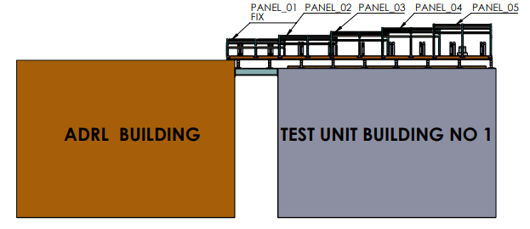

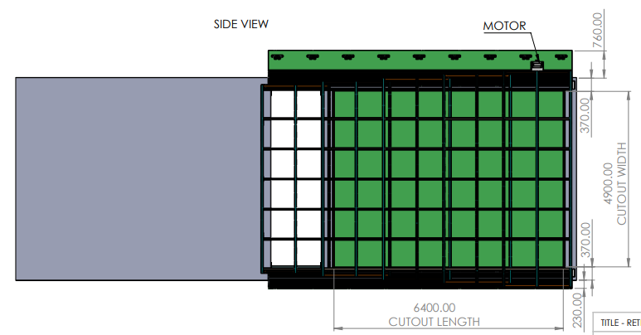

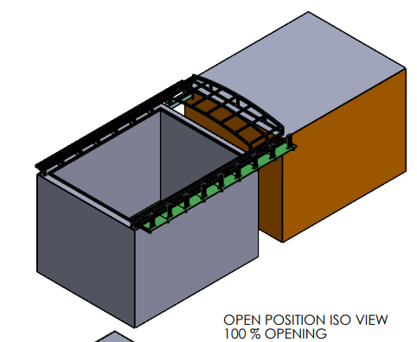

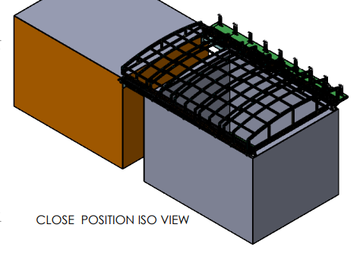

J. ROUTINE MAINTENANCE AND LUBRICATION

These recommendations are applicable to the Retractable Roof considering average daily usage of 05 to 10 times. If it is used more frequently, the same time intervals for the maintenance should be adjusted accordingly.

DAILY:
- Check Motor Auto/Manual mode for smooth operation.
- Check electrical connections for their proper working.

MONTHLY:
- Grease the rack and Pinion.
- Check Tightening of Bolt
- Check the Fuse of Remote

- Check the cell charging of Remote
- In case of Push Button, check the wire connection of switches.
- Check the alignment of Roof.

K. SPARE PARTS LIST

Sr no | Serial Number | Details | Image
1 | 20021245 | Nylon Wheel | 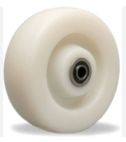
2 | 20021246 | Remote Cell | 
3 | 20021247 | Remote Fuse | 
4 | 20021248 | Push Button | 
5 | 20021249 | Rack | 
6 | 20021250 | Pinion | 
7 | 20021251 | SS Hardware | 
8 | 20021252 | Interlocking Nylon Pad | 
9 | 20021253 | Limit Switch | 
10 | 20021254 | Motor Key | 
11 | 20021255 | EPDM Rubber | 

